XSS and browser trust
Introduction and Lab Report
Lab: Stored XSS into HTML context with nothing encoded — PortSwigger Web Security Academy
Prepared by: Nihar Mane

INDEX
Part 1: INTRODUCTION

What is cross-site scripting (XSS) and how does it work?................................................2
Types of Cross-scripting (XSS) attacks……………………………………………………….2

Part 2: LAB REPORT

Report Metadata ……………………………………………………………………….……….4
Executive Summary…………………………………………………………………………….4
Scope …………………………………………………………………………………………….4
Methodology……………………………………………………………………………………..4
Step-by-step Procedure………………………………………………………………………...4
Impact Assessment……………………………………………………………………………..5
Remediation……………………………………………………………………………………..5
Conclusion……………………………………………………………………………………….5
References……………………………………………………………………………………….6

Part 1: INTRODUCTION

- What is cross-site scripting (XSS) and how does it work?

Cross-site scripting (XSS) is a web security vulnerability that occurs when an attacker has an ability to affect the interaction of the user with the vulnerable web application. It may also enable the attacker to bypass the security mechanisms, such as the same-origin policy, which are designed to isolate the different websites. Usually, cross-site scripting flaws allow attackers to impersonate the victim users and gain access to all of their privileges in order to perform any actions they are allowed to do. This kind of breach can be performed by tricking the vulnerable page into sending some malicious JavaScript code to the user’s browser, after which it will be executed within the context of the victim’s session. Cross-site scripting is also dangerous because it allows the attacker to completely hijack the user’s session and take full control over his or her account and all associated information.

- Types of Cross-scripting (XSS) attacks.

There are 3 types of cross-scripting (XSS) attacks:

- Reflected XSS: where the malicious script comes from the current HTTP request.
- Stored XSS: where the malicious script comes from the website's database.
- DOM-based XSS: where the vulnerability exists in client-side code rather than server-side code.

- Reflected XSS: When a program takes data from an HTTP request, usually a URL argument, and incorporates it directly into the response, without properly sanitizing it, this is known as reflected cross-site scripting (XSS). The script then executes in the browser of the victim during his or her session with the program when the attacker has generated a link with script content in that argument and induced the victim to follow it. Reflected XSS is generally considered to have less impact than stored XSS since each strike must be externally delivered (a phishing link, an email, or a malicious page) because the payload is not kept anywhere. Nonetheless, it can completely compromise the victim by taking over their session, reading or modifying data they have access to, and performing actions as them.

- Stored XSS: Stored XSS (also known as persistent or second-order XSS) happens when an application takes user-provided data, such as a comment, username, or input field value, and stores it somewhere in the application and later displays this data back to other users without sanitization. By submitting code as the request content, the attacker will manage to store the script on the server, and every user that loads a page with the script will be vulnerable to an attack in their own session. Since the payload is stored on the server-side, no additional interaction is needed for the exploitation to happen, and so stored XSS are also common and more dangerous than reflected ones. This vector is especially dangerous for users who are logged in when visiting a page with malicious code.

- DOM-based XSS: DOM-based XSS attacks are based completely on the client side. With this type of attack, the existing JavaScript code on the page takes data from an external source controlled by the attacker (typically the URL, using window.location) and passes this data to a "sink," such as eval() or innerHTML, without sanitizing it first. Unlike reflected and stored XSS, the server may never actually see the malicious data at all; vulnerable code flow (source to sink) is contained within the page's own scripts, making it invisible to server-side filters or logs. An attacker will typically deliver this as a URL, including their malicious data in the query string or fragment, which then gets executed in the victim's browser if they view this URL and the page makes unsafe use of it. This can allow hijacking of the victim's session, just as with reflected and stored XSS attacks.

PART 2: LAB REPORT

- Metadata
Lab: Stored XSS into HTML context with nothing encoded — PortSwigger Web Security Academy (Apprentice). Target: /post?postId=<id> comment form. Tools: Burp Suite Community Edition, Chromium-based lab browser.

- Executive Summary
This lab demonstrates stored XSS in a blog’s comment field, which renders submitted comments in the page’s HTML without any encoding. Submitting <script>alert(1)</script> as a comment causes the script to execute for every visitor who views that blog post, confirming the lab as solved.

- Scope
In scope: the comment form on the assigned PortSwigger lab instance.
Out of scope: all other endpoints and any production system.

- Methodology
Submit a script payload in the comment field, along with a name, email, and website, then post the comment and observe whether it executes when the page reloads.

- Step-by-step Procedure

Step 1: We access a lab blog and under it in the comments section we add <script>alert(1)</script> along with entering a name, email, and website. After Submitting the lab is solved.

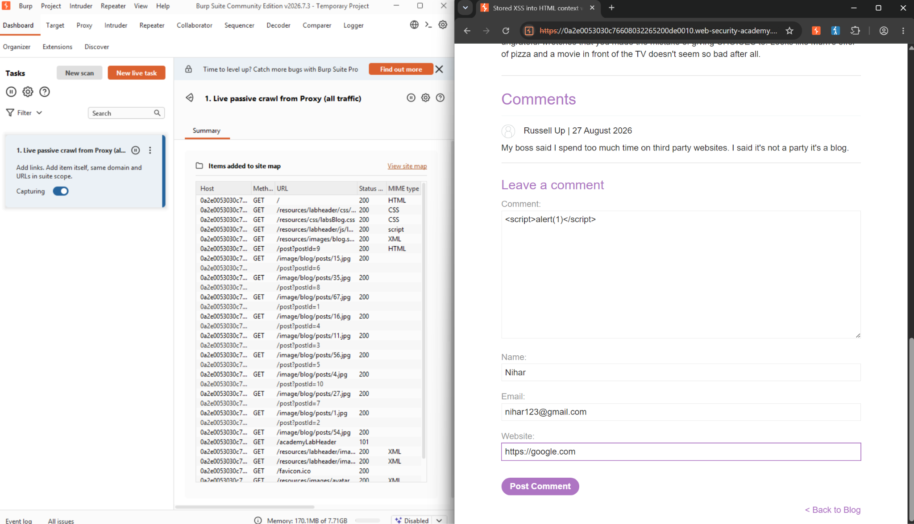

- Impact Assessment
• Session hijacking: the payload runs in every visitor’s browser within their own session.
• Persistent, self-contained attack: no phishing link or social engineering is needed once the comment is posted.
• Broad reach: every user who views the blog post is affected, including logged-in users.

- Remediation
• HTML-encode comment output (and all user-supplied fields) before rendering it on the page.
• Validate and sanitize input on arrival, rejecting or stripping script tags and event handlers.
• Apply a content security policy to restrict inline script execution as defence in depth.

- Conclusion
• HTML-encode comment output (and all user-supplied fields) before rendering it on the page.
• Validate and sanitize input on arrival, rejecting or stripping script tags and event handlers.
• Apply a content security policy to restrict inline script execution as defense in depth.

REFERENCES:

- What is cross-site scripting (XSS) and how does it work?
https://portswigger.net/web-security/cross-site-scripting#what-is-cross-site-scripting-xss

- Types of Cross-scripting (XSS) attacks
https://portswigger.net/web-security/cross-site-scripting/reflected
https://portswigger.net/web-security/cross-site-scripting/stored
https://portswigger.net/web-security/cross-site-scripting/dom-based

- LAB: Stored XSS into HTML context with nothing encoded
https://portswigger.net/web-security/cross-site-scripting/stored/lab-html-context-nothing-encoded

